**How to deploy a WAR file in Tomcat**

1. First

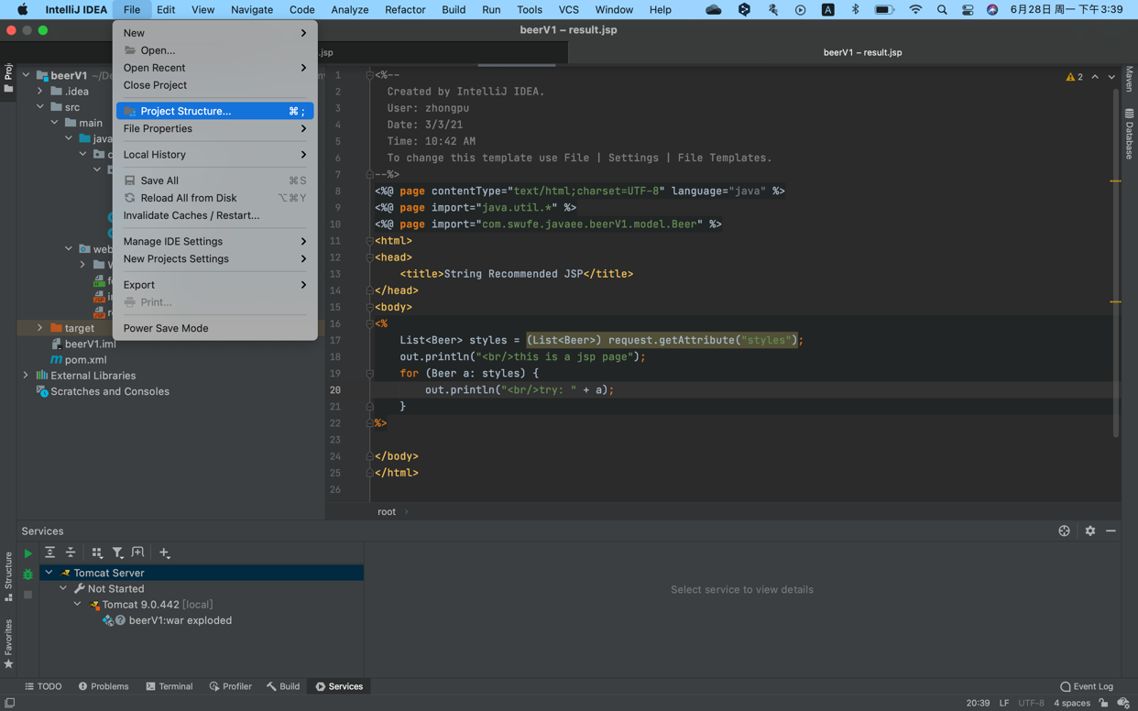

1. Set path

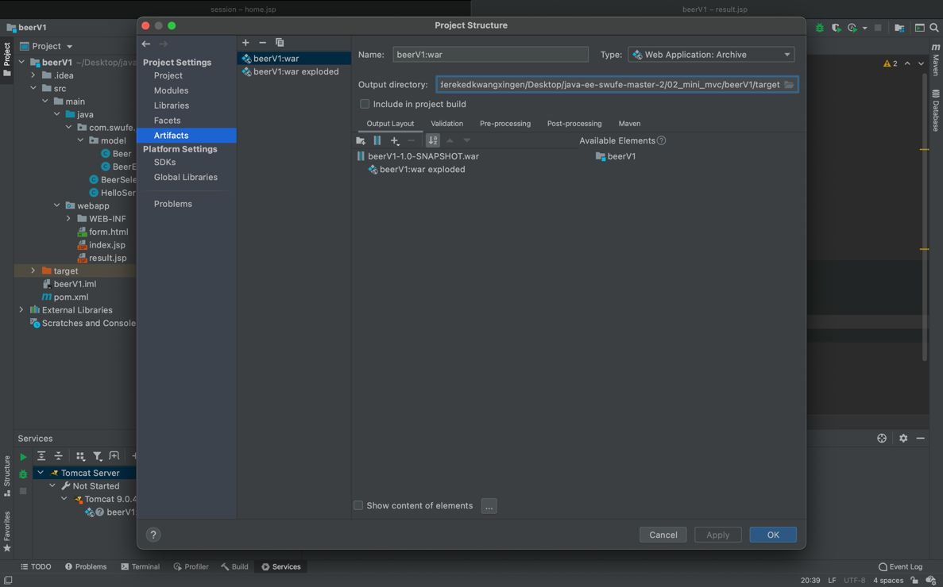

1. Build a WAR file to the path you set

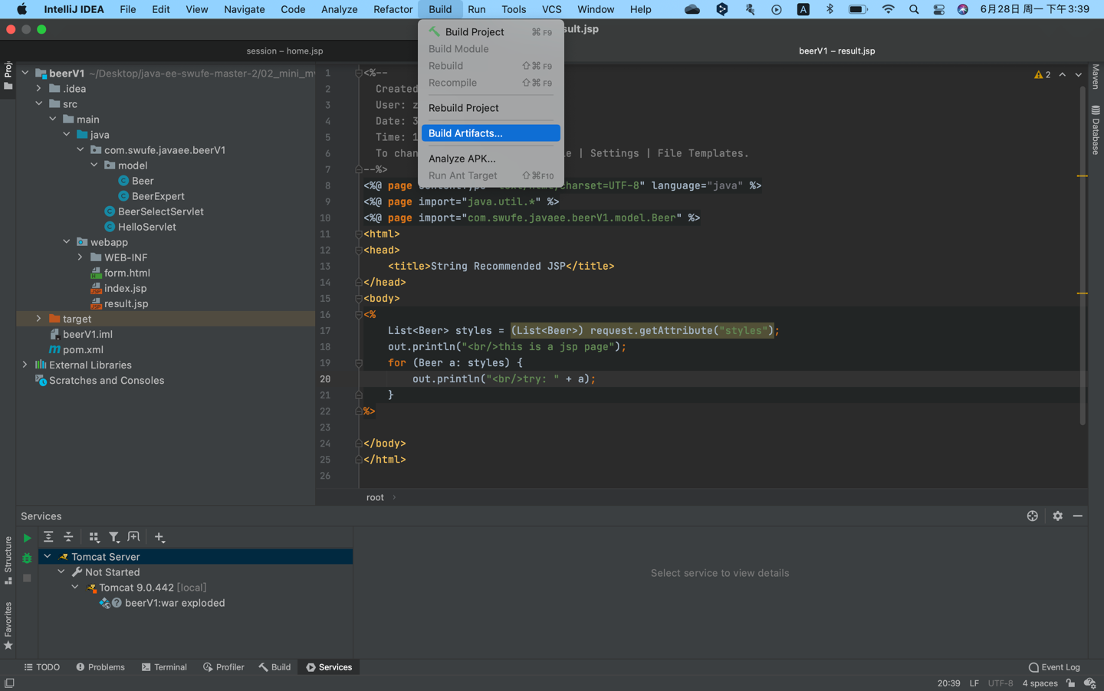 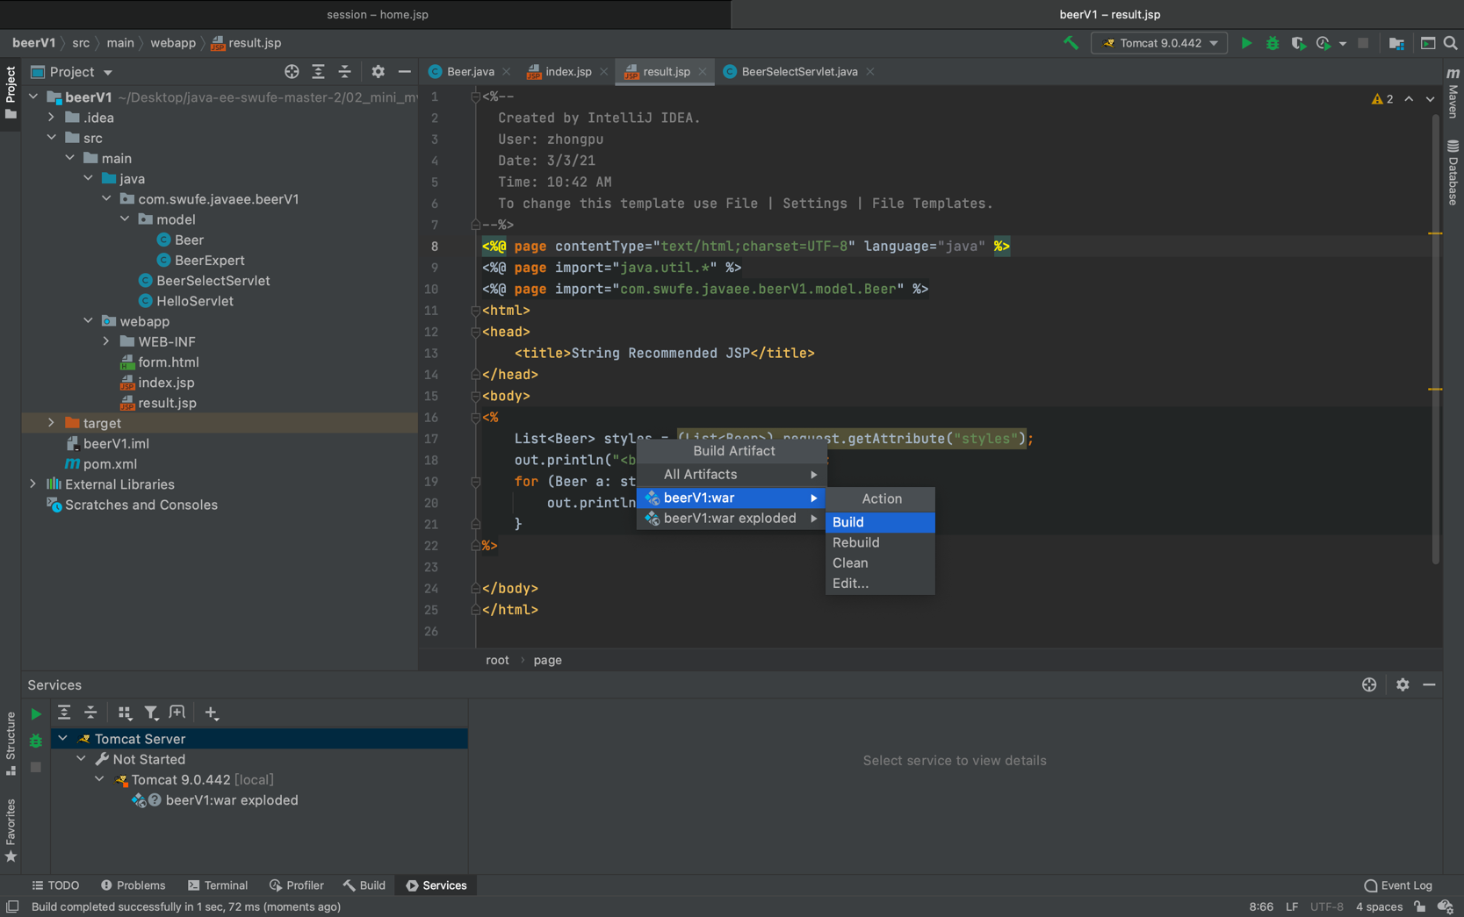

1. Copy the WAR file and paste it under the WebApp folder

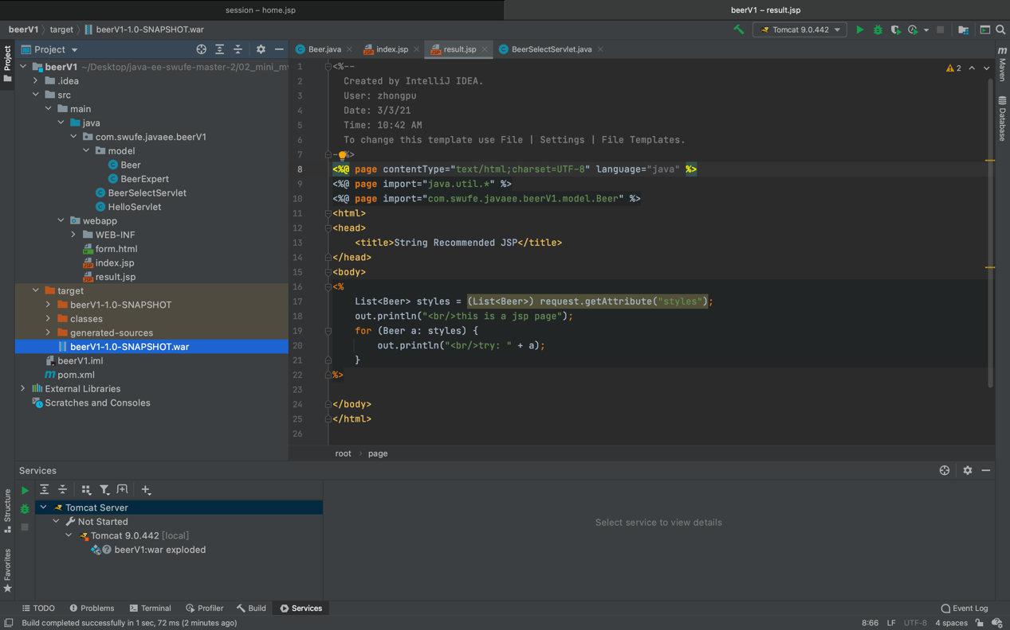 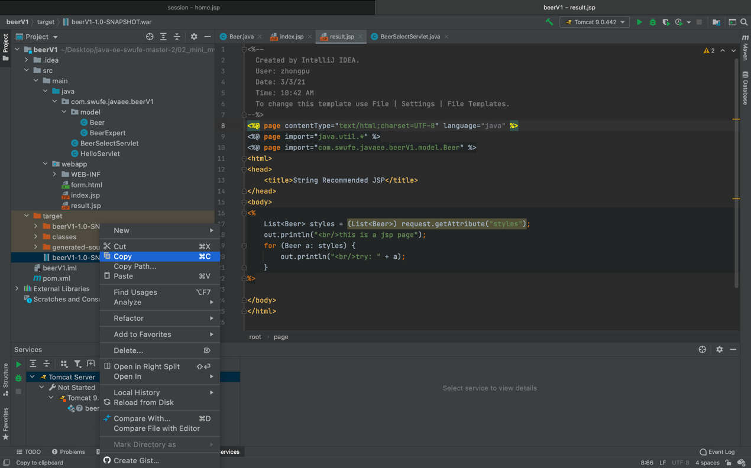

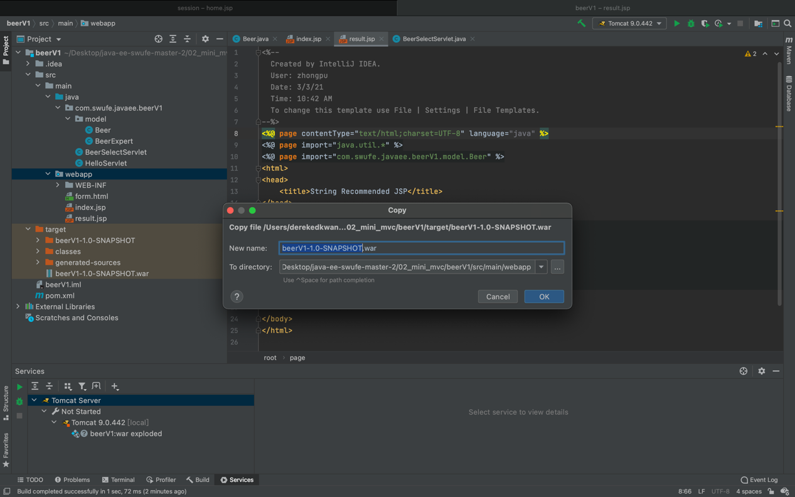

1. Now we deployed successfully

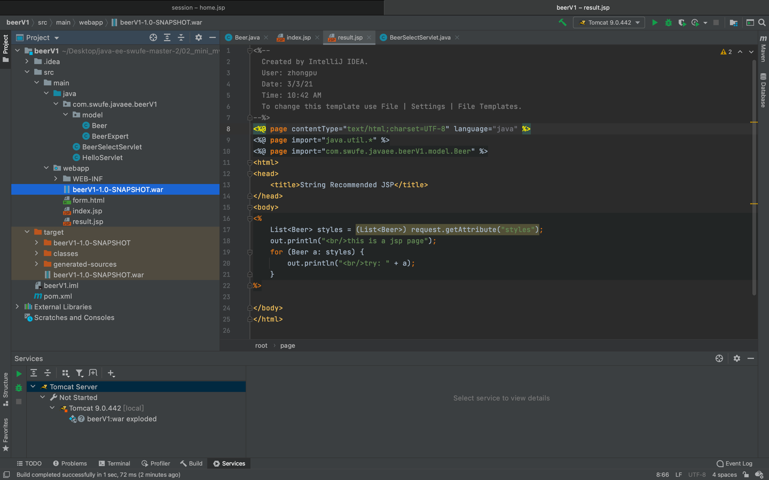

References:

<https://www.theserverside.com/blog/Coffee-Talk-Java-News-Stories-and-Opinions/Top-5-ways-to-deploy-a-WAR-file-to-Tomcat>

